WEEK 4 – MICROSERVICES
Creating microservices for account and loan:
Account
AccountController.java
package com.cognizant.account.controller;
import com.cognizant.account.model.Account;
import org.springframework.web.bind.annotation.GetMapping;
import org.springframework.web.bind.annotation.PathVariable;
import org.springframework.web.bind.annotation.RestController;
@RestController
public class AccountController {
@GetMapping("/accounts/{number}")
public Account getAccount(@PathVariable String number) {
Account account = new Account();
account.setNumber(number);
account.setType("savings");
account.setBalance(234343);
// Display in IntelliJ console
System.out.println("Account Number : " + account.getNumber());
System.out.println("Account Type : " + account.getType());
System.out.println("Balance : " + account.getBalance());
return account;
}
}
Account.java
package com.cognizant.account.model;
public class Account {
private String number;
private String type;
private double balance;
public Account() {
}
public Account(String number, String type, double balance) {
this.number = number;
this.type = type;
this.balance = balance;
}
public String getNumber() {
return number;
}
public void setNumber(String number) {
this.number = number;
}
public String getType() {
return type;
}
public void setType(String type) {
this.type = type;
}
public double getBalance() {
return balance;
}
public void setBalance(double balance) {
this.balance = balance;
}
}
Applicationproperties
spring.application.name=account
server.port=8080

AccountApplication.java
package com.cognizant.account;
import org.springframework.boot.SpringApplication;
import org.springframework.boot.autoconfigure.SpringBootApplication;
@SpringBootApplication
public class AccountApplication {
public static void main(String[] args) {
SpringApplication.run(AccountApplication.class, args);
}
}
pom.xml
<?xml version="1.0" encoding="UTF-8"?>
<project xmlns="http://maven.apache.org/POM/4.0.0" xmlns:xsi="http://www.w3.org/2001/XMLSchema-instance"
xsi:schemaLocation="http://maven.apache.org/POM/4.0.0 https://maven.apache.org/xsd/maven-4.0.0.xsd">
<modelVersion>4.0.0</modelVersion>
<parent>
<groupId>org.springframework.boot</groupId>
<artifactId>spring-boot-starter-parent</artifactId>
<version>4.1.0</version>
<relativePath/> <!-- lookup parent from repository -->
</parent>
<groupId>com.cognizant</groupId>
<artifactId>account</artifactId>
<version>0.0.1-SNAPSHOT</version>
<name>account</name>
<description>account</description>
<url/>
<licenses>
<license/>
</licenses>
<developers>
<developer/>
</developers>
<scm>
<connection/>
<developerConnection/>
<tag/>
<url/>
</scm>
<properties>
<java.version>17</java.version>
</properties>
<dependencies>
<dependency>
<groupId>org.springframework.boot</groupId>
<artifactId>spring-boot-starter</artifactId>
</dependency>
<dependency>
<groupId>org.springframework.boot</groupId>
<artifactId>spring-boot-starter-test</artifactId>
<scope>test</scope>
</dependency>
<dependency>
<groupId>org.springframework.boot</groupId>
<artifactId>spring-boot-starter-web</artifactId>
</dependency>
</dependencies>
<build>
<plugins>
<plugin>
<groupId>org.springframework.boot</groupId>
<artifactId>spring-boot-maven-plugin</artifactId>
</plugin>
</plugins>
</build>
</project>
Output:
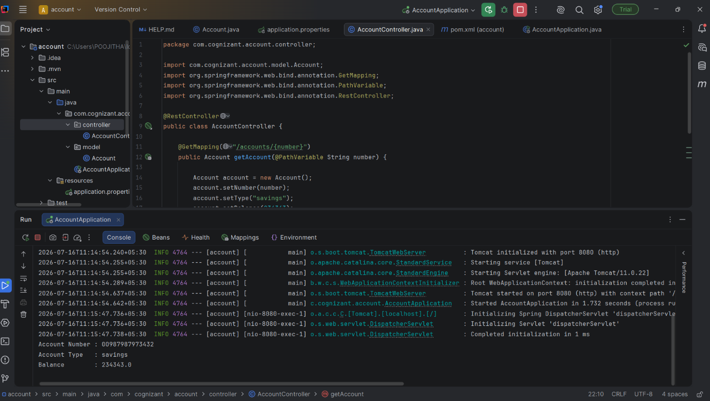

Loan:
LoanController.java
package com.cognizant.loan.controller;
import org.springframework.web.bind.annotation.*;
@RestController
public class LoanController {
@GetMapping("/loan")
public String getLoanDetails() {
System.out.println("----- Loan Details -----");
System.out.println("Loan Type : Home Loan");
System.out.println("Loan Amount : 500000");
System.out.println("Loan Status : Approved");
System.out.println("------------------------");
return "Loan details printed in console";
}
}
Loan.java
package com.cognizant.loan.model;
public class Loan {
private String number;
private String type;
private double loan;
private double emi;
private int tenure;
public Loan() {
}
public Loan(String number, String type, double loan, double emi, int tenure) {
this.number = number;
this.type = type;
this.loan = loan;
this.emi = emi;
this.tenure = tenure;
}
public String getNumber() {
return number;
}
public void setNumber(String number) {
this.number = number;
}
public String getType() {
return type;
}
public void setType(String type) {
this.type = type;
}
public double getLoan() {
return loan;
}
public void setLoan(double loan) {
this.loan = loan;
}
public double getEmi() {
return emi;
}
public void setEmi(double emi) {
this.emi = emi;
}
public int getTenure() {
return tenure;
}
public void setTenure(int tenure) {
this.tenure = tenure;
}
}
pom.xml
<?xml version="1.0" encoding="UTF-8"?>
<project xmlns="http://maven.apache.org/POM/4.0.0"
xmlns:xsi="http://www.w3.org/2001/XMLSchema-instance"
xsi:schemaLocation="https://maven.apache.org/POM/4.0.0 https://maven.apache.org/xsd/maven-4.0.0.xsd">
<modelVersion>4.0.0</modelVersion>
<parent>
<groupId>org.springframework.boot</groupId>
<artifactId>spring-boot-starter-parent</artifactId>
<version>4.1.0</version>
<relativePath/>
</parent>
<groupId>com.cognizant</groupId>
<artifactId>loan</artifactId>
<version>0.0.1-SNAPSHOT</version>
<name>loan</name>
<description>Loan Microservice</description>
<properties>
<java.version>17</java.version>
</properties>
<dependencies>
<dependency>
<groupId>org.springframework.boot</groupId>
<artifactId>spring-boot-starter-web</artifactId>
</dependency>
<dependency>
<groupId>org.springframework.boot</groupId>
<artifactId>spring-boot-starter-test</artifactId>
<scope>test</scope>
</dependency>
</dependencies>
<build>
<plugins>
<plugin>
<groupId>org.springframework.boot</groupId>
<artifactId>spring-boot-maven-plugin</artifactId>
</plugin>
</plugins>
</build>
</project>

Application.properties
spring.application.name=loan
server.port=8081

LoanApplication.java
package com.cognizant.loan;
import org.springframework.boot.SpringApplication;
import org.springframework.boot.autoconfigure.SpringBootApplication;
@SpringBootApplication
public class LoanApplication {
public static void main(String[] args) {
SpringApplication.run(LoanApplication.class, args);
}
}
Output:
